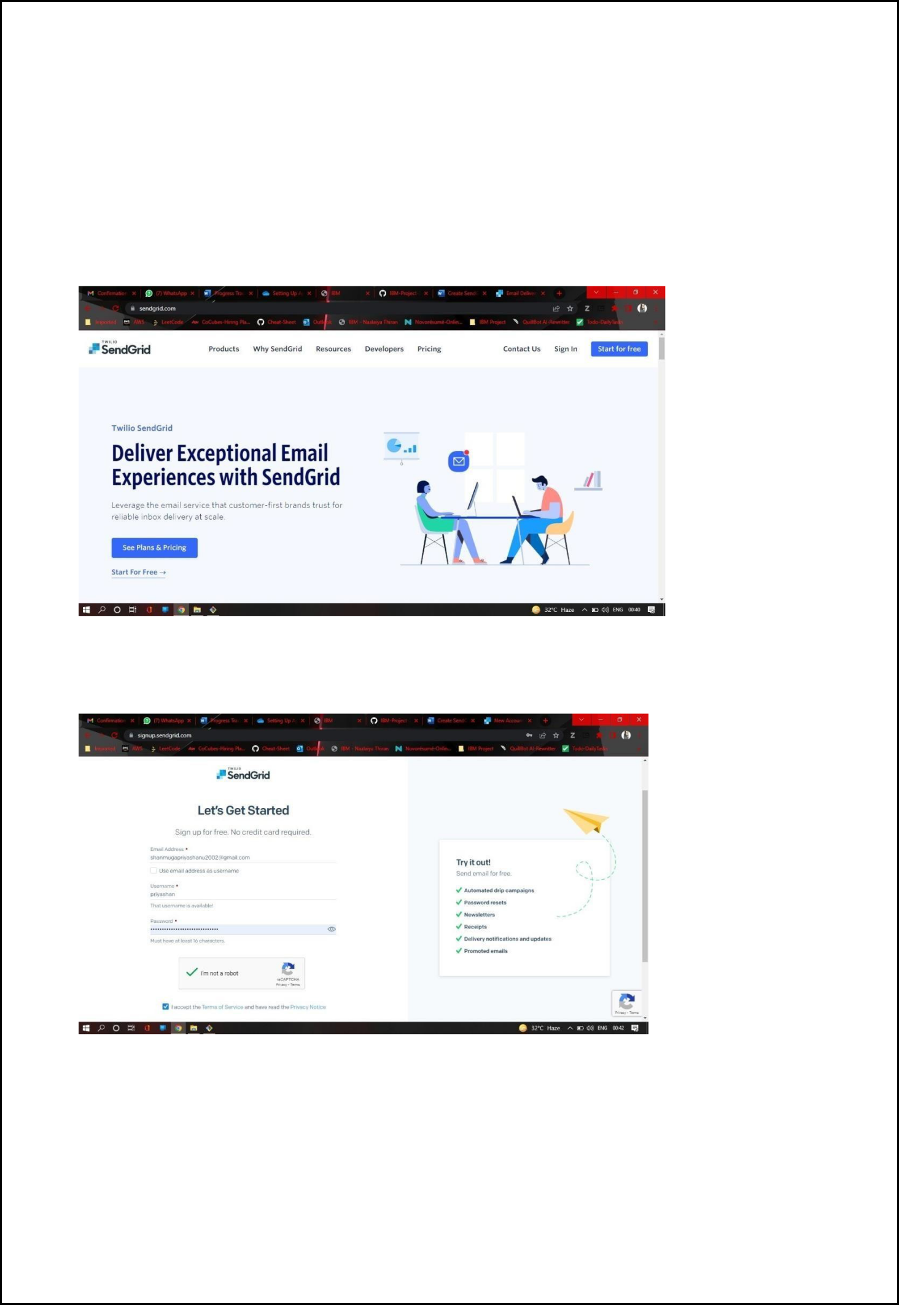
Plasma Donor Application Team ID: PNT2022TMID04418

Setting up Application Environment

Create Sendgrid Account

Step 1. Navigate to https://sendgrid.com

Step 2. Click on “Start for free” and register yourselves by entering required details and click on create account

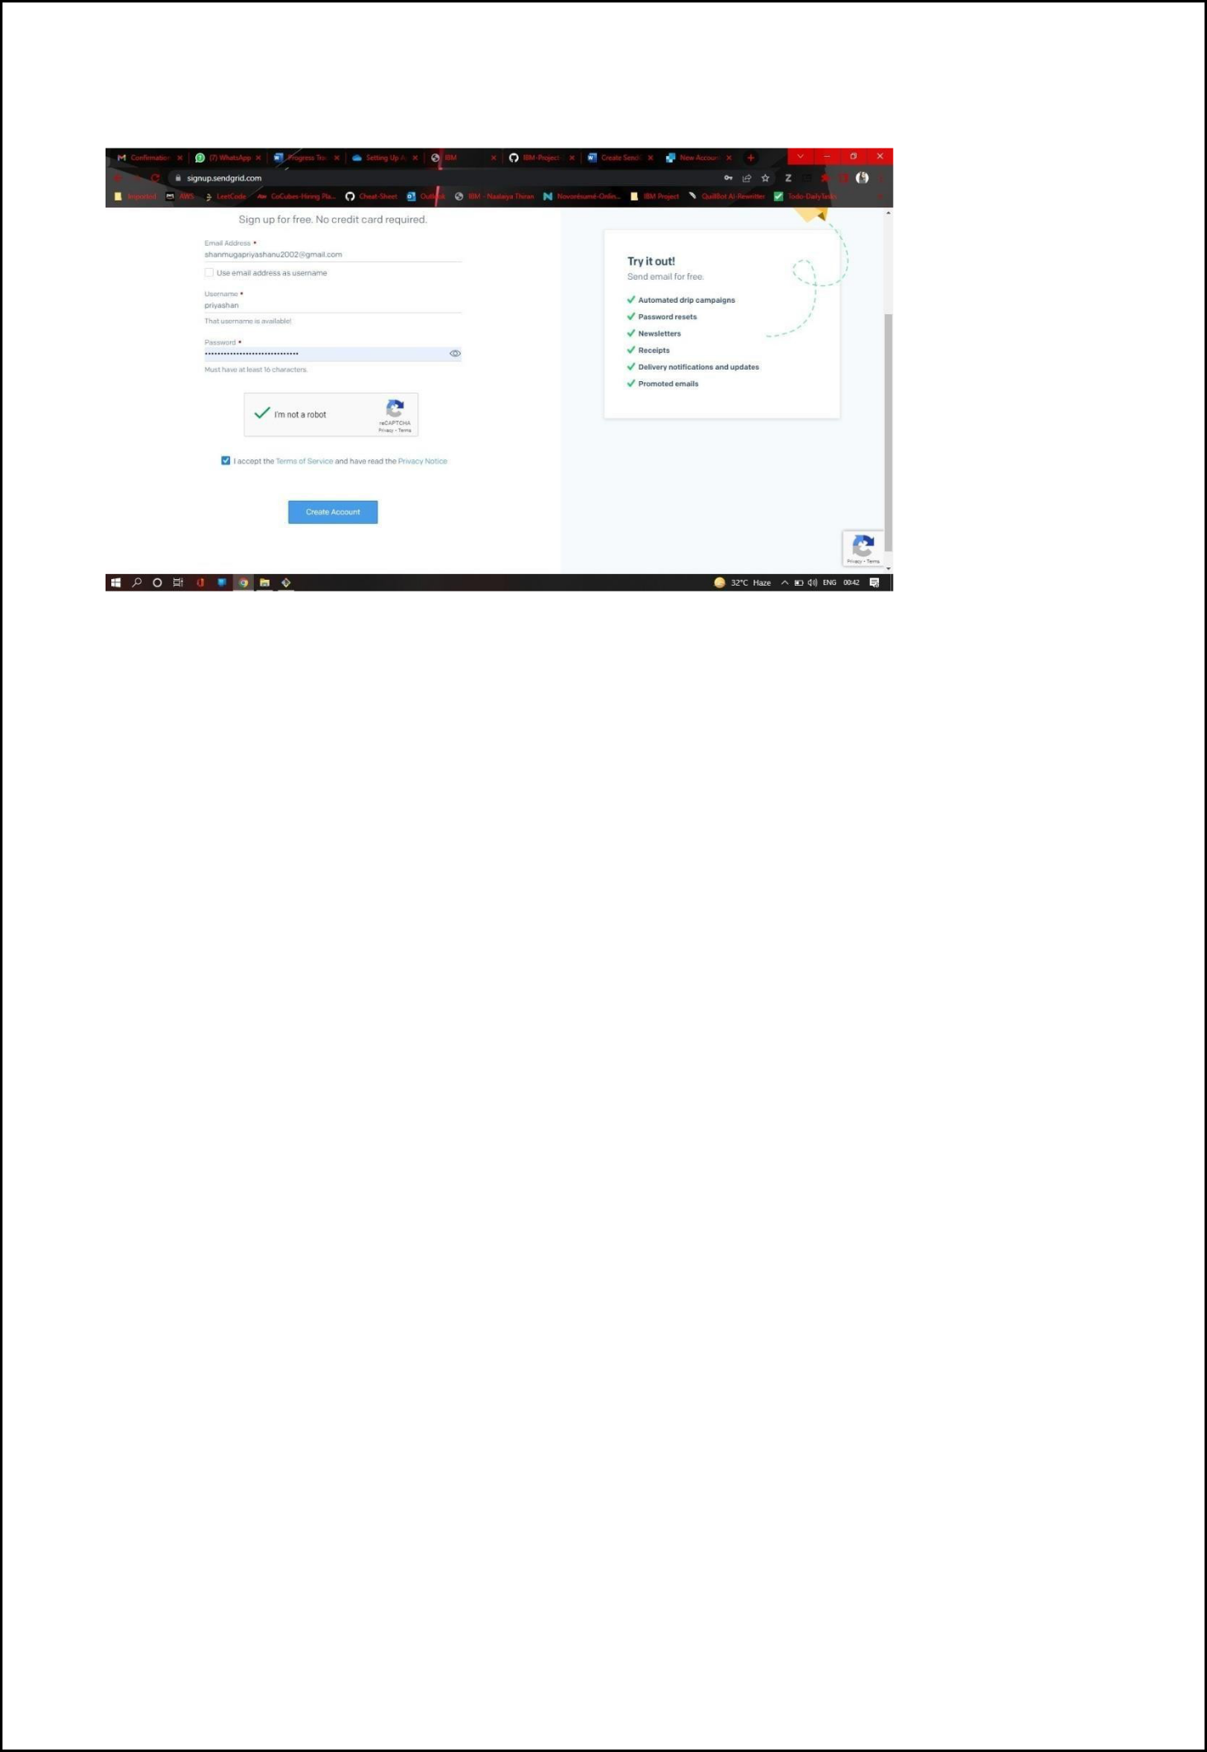
Plasma Donor Application Team ID: PNT2022TMID04418

Step 3. Further fill all required details in next page and click on get started as shown below

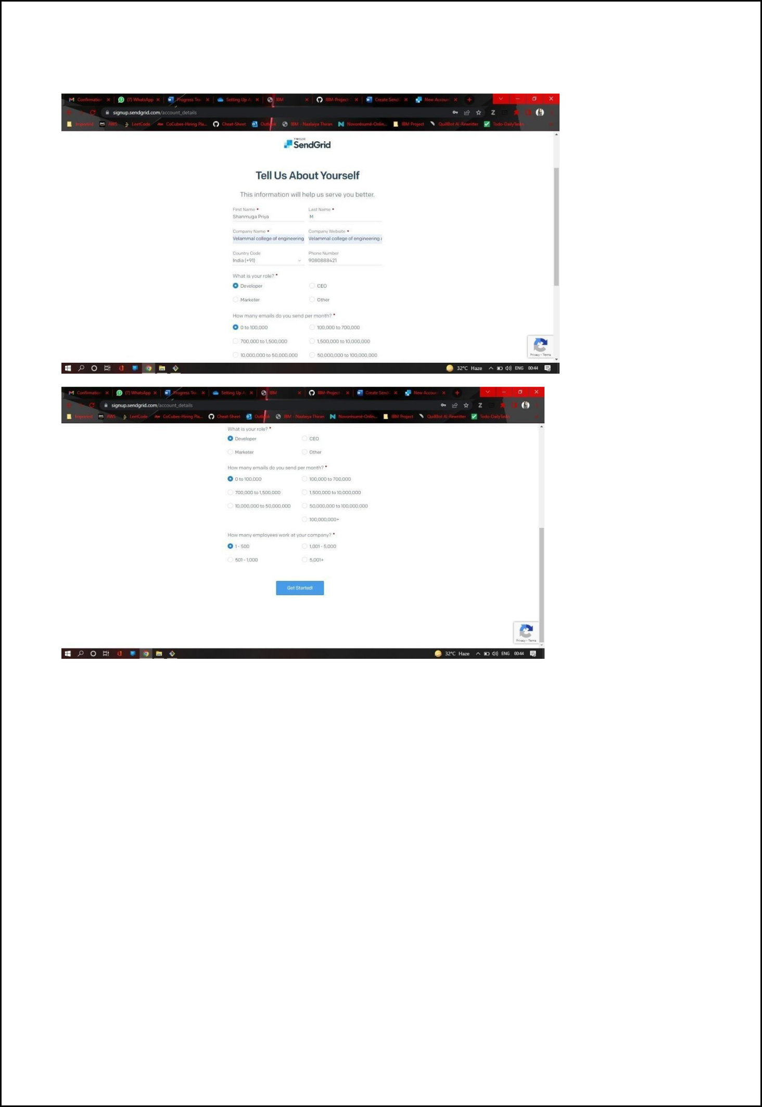
Plasma Donor Application Team ID: PNT2022TMID04418

Step 4. That’s it you have created your SendGrid account and got access to dashboard

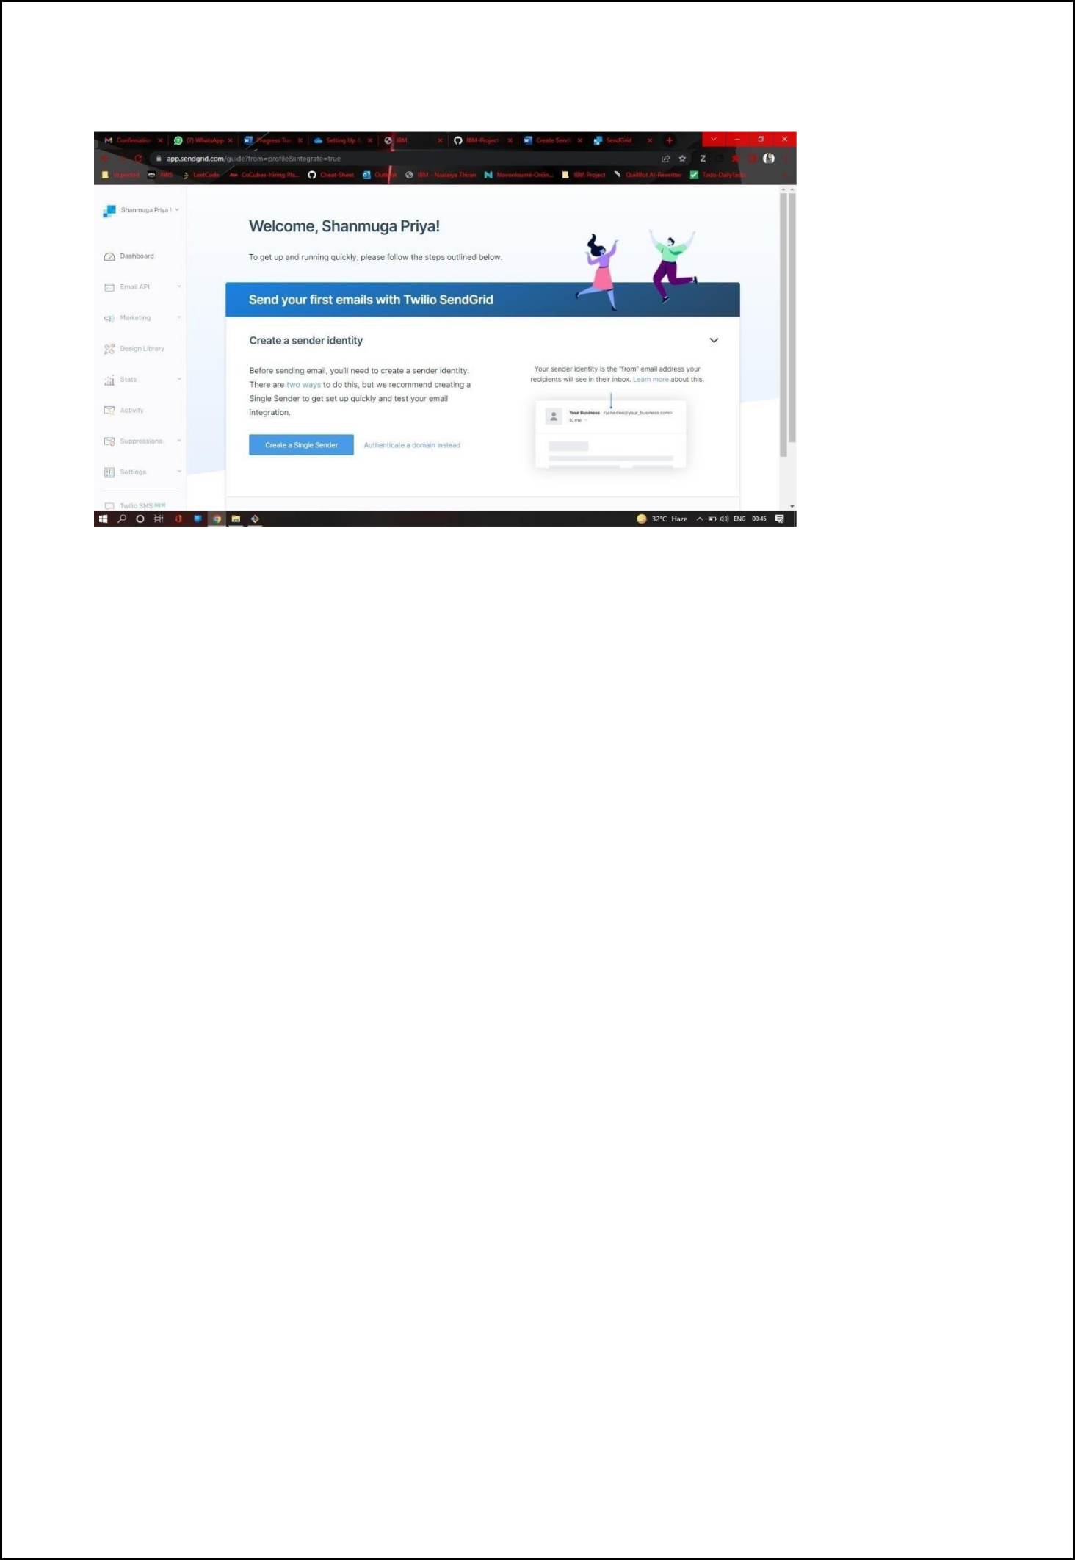
Plasma Donor Application Team ID: PNT2022TMID04418

Output:

Send Grid account created successfully.

